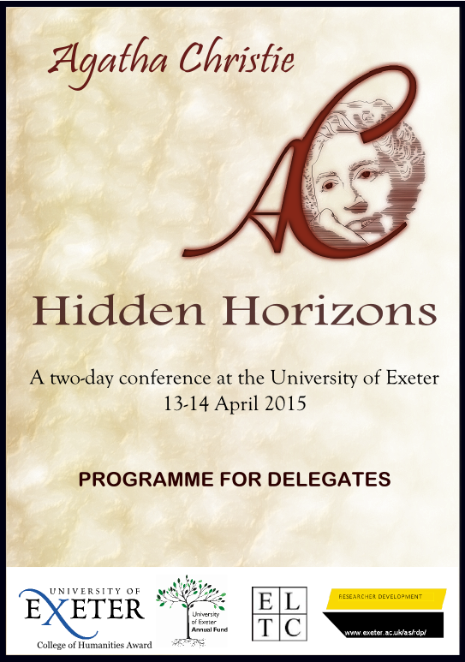

SPONSORS

The organisers gratefully acknowledge financial support from:

* The University of Exeter Annual Fund
* The University of Exeter Humanities Award
* Research Development, University of Exeter

We are thankful to Freja Steele for designing our swanky logo.

We are grateful to The Imperial, For Books’ Sake, and the Exeter Little Theatre Company for making the conference extras possible.

Jamie Bernthal
Mia Dormer
AGATHA CHRISTIE: HIDDEN HORIZONS

Day One
09:00-09:30 Registration with refreshments
09:30-11.00 Keynote: Sophie Hannah
11:00-11:15 Coffee break
11:15-12:45 Panel 1: Twisting the Genre
12:45-13:30 Lunch
13:30-15:00 Panel 2: Clues
15:00-16:30 Panel 3: Gender
16:30-17:00 Coffee break
17:00-18:30 Keynote: Gill Plain

20:00 – Conference dinner and pub quiz at the Imperial (optional)

Day 2
10:00-11:30 Panel 4: Re/vision
11:30-11:45 Coffee break
11:45-13:15 Keynote: John Curran
13:15-14:00 Lunch
14:00-15:30 Panel 5: Screen and Culture
15:30-16:00 Coffee break
16:00-17:00 Panel 6: Rethinking Agatha Christie
17:00-17:15 Conference close
17:15-18:30 Wine reception with informal discussion

19:30 – VIP performance of Murder on the Nile at the Barnfield (optional)

PARTICIPANTS AND TOPICS
DAY ONE

Keynote: Sophie Hannah (Title TBC)

Panel 1: Twisting the Genre
Marta Zago
Rhyme and Reason: Nursery Rhymes as Deception Tools
Stuart Barnett (Central Connecticut State University)
The Fiction of Genre: From Politics to Ethics in Agatha Christie
Meg Boulton
‘Hidden Secrets’: Archaeology and Deductive Processes in Agatha Christie's Poirot

Panel 2: Clues
Mia Dormer (University of Exeter)
Forensic Science in The Hollow
Michelle M. Kazmer (Florida State University)
‘Yet Something Pipeth Like a Bird’: Information Behaviour, With No Actor?
Chrissie Poulter (Trinity College, Dublin)
Agatha Christie Swept Under Her Carpet: Domestic Detail and TV Adaptation

Panel 3: Gender
Merja Makinen (Middlesex University)
Hidden in Full View: Mary Westmacott’s Critique of Gender
Alan Hooker (University of Exeter)
‘Just Sly, Quiet Old Women’: Witches and the Supernatural in Agatha Christie
Rebecca Mills (University of Exeter)
‘Son of the Morning’: Gender and Beauty in Agatha Christie's Poetics of Evil

Keynote: Gill Plain (Title TBC)

PARTICIPANTS AND TOPICS
DAY TWO

Panel 4: Re/vision
Ahmet Atay (College of Wooster)
Walking Through Poirot’s London: Reimagining Mediated Texts through Ethnographic Explorations
Brigitta Hudácskó (University of Debrecen)
Inventing History: Agatha Christie and Katalin Baráth’s Middlebrow Series
Trisha Ray
Body on a Steam-Launch: A Poirot Pastiche

Keynote: John Curran Endless Night: A Flawed Masterpiece

Panel 5: Screen and Culture
Mark Aldridge (Southampton Solent University)
Agatha Christie’s Early Adventures at the BBC
Marjolijn Storm (Saarbrücken University)
Agatha Christie and the Mega-Polysystem of Detective Fiction: The German Films Die Abenteuer G.m.b.H. (1929) and Orientexpress (1944)
Sarah Street (University of Bristol)
Heritage Crime: The Case of Agatha Christie

Panel 6: Rethinking Agatha Christie
Anna Farthing (International Agatha Christie Festival)
Agatha Christie: Life, Literature and Legacy. Curating the International Agatha Christie Festival in Torquay on the 125th Anniversary of her Birth.
Carly Mays (National Trust at Greenway House)
A Closer Look at Greenway

KEYNOTE SPEAKERS

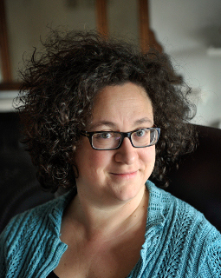

Sophie Hannah is an internationally best-selling writer of psychological crime fiction, published in 27 countries. She is the author of The Monogram Murders, the first Hercule Poirot novel since Agatha Christie’s death.

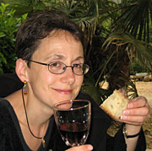

Professor Gill Plain is Head of the School of English at the University of St. Andrews. She is an authority on war writing, and is co-founder of the research network WAR-Net. Her monograph Twentieth Century Crime Fiction: Gender, Sexuality and the Body is seminal.

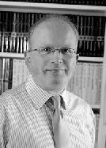

Dr. John Curran is a recognized authority on all things Agatha Christie and is the author of Agatha Christie’s Secret Notebooks. He is a lifelong Christie fan, who has had unprecedented access to archived materials.

YOUR NOTES

